

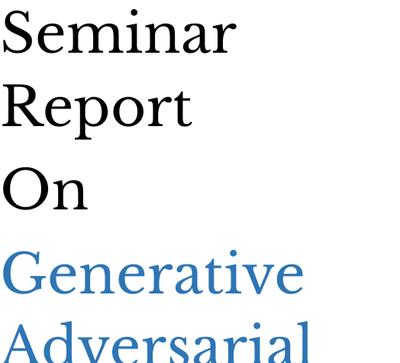

# INSTITUTE of MANAGEMENT and INFORMATION TECHNOLOGY

Guided By:

Mrs. Sujata Ray

Presented By:

Arjit Kumar Mohapatra

Regd. No.- 2205102012

MCA 3rd Semester 2024

ACKNOWLEDGEMENT

I am highly indebted to my seminar guide Mrs.Sujata Ray for inspiration and support in preparing this seminar report on “Generative Adversarial Networks”. They provide a constant source of guidance and helped a lot.

I also acknowledge the continuous support and encouragement given by all other faculty member of department of MCA and which made the seminar report pleasant and enjoyable.

NAME: Arjit Kumar Mohapatra

REGD NO:22051012

3RD SEMESTER, MCA

CERTIFICATE

This is to be certify that I, Arjit Kumar Mohapatra of 3rd semester MCA, Section-A have successfully completed and presented a seminar report on “Generative Adversarial Networks” within the stipulated time Period under the guidance of

Mrs. Sujata Ray

SEMINAR GUIDE

Content

1. Abstract
2. Introduction to GANs
3. Generative Modeling
4. How GANs work?
5. Applications of GANs
6. Advantages and disadvantages of GANs
7. Conclusion

### Abstract

Generative adversarial networks are a kind of artificial intelligence algorithm designed to solve the generative modelling problem. The goal of a generative model is to study a collection of training examples and learn the probability distribution that generated them. Generative Adversarial Networks (GANs) are then able to generate more examples from the estimated probability distribution. Generative models based on deep learning are common, but GANs are among the most successful generative models (especially in terms of their ability to generate realistic high-resolution images). GANs have been successfully applied

to a wide variety of tasks (mostly in research settings) but continue to present unique challenges and research opportunities because they are based on game theory while most other approaches to generative modeling are based on optimization.

### Introduction to GANs

In the realm of artificial intelligence, Generative Adversarial Networks (GANs) stand as pioneers, reshaping the landscape of image synthesis and beyond. This seminar report offers a captivating introduction to the revolutionary concept of GANs, a class of machine learning models that have transcended traditional boundaries.

At its core, a GAN comprises two neural networks, the generator, and the discriminator, engaged in a compelling dance of creation and critique. The generator crafts synthetic data, while the discriminator evaluates it against real-world examples. Through this adversarial interplay, GANs can generate remarkably realistic images, fostering advancements in various fields, including computer vision, art creation, and data augmentation.

As we delve into the intricacies of GANs, we explore their applications in generating lifelike faces, creating unique artworks, and even aiding in the development of autonomous vehicles. Additionally, we unravel the ethical considerations surrounding GANs, addressing concerns related to deepfakes and potential misuse.

As we unravel the captivating world of Generative Adversarial Networks, unlocking the potential for innovation and creativity that these AI marvels bring to the forefront of technological advancement.

### Generative Modelling

Imagine teaching a computer to paint, not by mimicking existing masterpieces, but by understanding the essence of art itself. This is the magic of generative modelling, a subfield of artificial intelligence that empowers machines to "dream up" new data that closely resembles the real world.

This article delves into the fascinating world of generative modelling, offering a glimpse into its potential and applications. We'll explore how these models learn hidden patterns within existing data, be it pictures, text, or even music. Through intricate statistical frameworks and powerful algorithms, they capture the essential characteristics – the brushstrokes, the wordsmithing, the melodies – and use them to create entirely new, yet authentic-looking content.

But why venture into this realm of data creation? The implications are vast. Generative models can revolutionize diverse fields:

* Art and Music: Generate personalized music albums that reflect your mood, or create art galleries filled with never-before-seen landscapes.
* Drug Discovery: Design new molecules with desired properties, accelerating the search for life-saving drugs.
* Material Science: Develop novel materials with specific functionalities, paving the way for innovative technologies.
* Software Development: Generate realistic test data for software, preventing bugs and enhancing functionality.

This is just the tip of the iceberg. As the field evolves, generative models hold the potential to reshape our understanding of data, creativity, and even the very nature of information itself.

Our research report takes a deeper dive into this exciting world, exploring various model types, training techniques, and specific applications. It delves into the challenges and limitations, sparking a dialogue about responsible development and ethical considerations.

Get ready to unlock the secrets of data, one generated pixel, word, or note at a time. This article is your invitation to explore the cutting edge of artificial intelligence and discover the boundless possibilities of generative modelling.

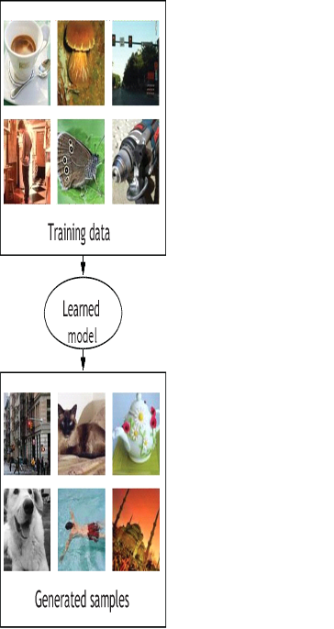

### How GANs work?

Imagine a master forger meticulously crafting counterfeit bills, while a seasoned detective scrutinizes them, striving to unveil the forger's tricks. This interplay forms the heart of Generative Adversarial Networks (GANs) - a powerful deep learning technique for generating novel data.

GANs consist of two neural networks: a generator and a discriminator. The generator generates new data, while the discriminator tries to distinguish between the generated data and real data. The generator tries to generate data that can fool the discriminator, while the discriminator tries to accurately distinguish between the two. The generator takes in random noise as input and generates new data.

The discriminator takes in both real and generated data and outputs a probability score, indicating whether the input data is real or generated. During training, the generator and discriminator are updated iteratively to improve their performance.

The goal of the generator is to produce data that is as similar as possible to real data, while the goal of the discriminator is to correctly identify whether the input data is real or generated. As the generator improves, the discriminator must also improve in order to maintain its accuracy. This creates a feedback loop that drives both networks to improve.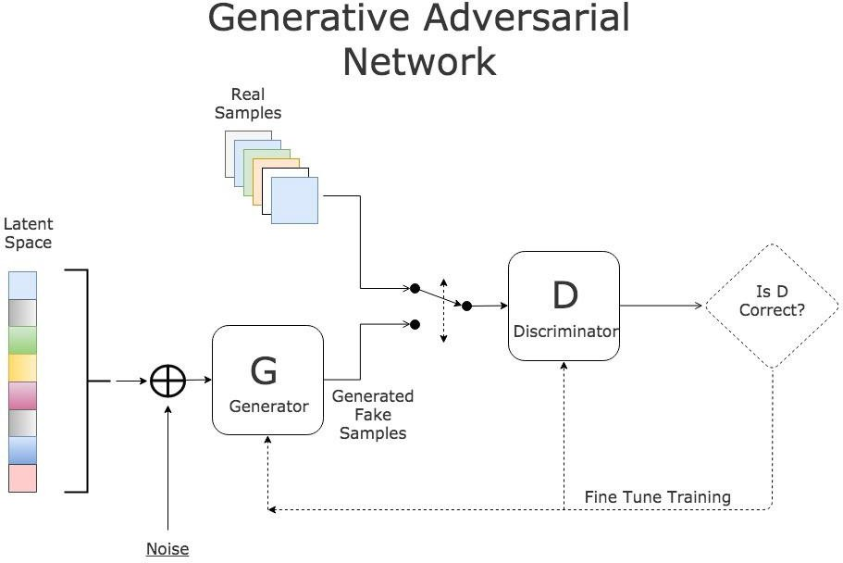

### Applications of GANs

Generative Adversarial Networks (GANs) have emerged as a powerful tool in AI, captivating the world with their ability to create realistic and creative outputs. In 2023, the applications of GANs are rapidly expanding beyond the realm of image generation, impacting diverse fields from healthcare to music composition.

1. Medical Imaging: GANs assist in early disease detection by generating high-quality synthetic medical images for training diagnostic algorithms. This addresses real-world limitations of data availability while also protecting patient privacy.

2. Drug Discovery: GANs accelerate the drug discovery process by generating novel molecules with desired properties, offering researchers a vast landscape of potential candidates for testing and analysis.

3. Personalized Medicine: GANs personalize medical treatments by tailoring drug dosage and therapy plans based on individual patient data. This allows for more effective and efficient healthcare, reducing potential side effects.

4. Content Creation: Beyond images, GANs are now generating realistic and engaging videos, music, and even text. This has applications in animation, film, video game development, and even personalized content tailoring for individual users.

5. Data Augmentation: GANs address the challenge of limited data sets by generating realistic synthetic data, enhancing the performance of machine learning models in various domains, from speech recognition to self-driving cars.

6. Style Transfer: GANs can transfer artistic styles across different mediums. Imagine applying the brushstrokes of Van Gogh to your vacation photos, or composing music in the style of Mozart – the possibilities are endless.

The future of GANs is brimming with potential. Research is pushing the boundaries of realism and control, while addressing ethical concerns surrounding deepfakes and potential misuse. As GANs continue to evolve, they will undoubtedly revolutionize diverse fields, fostering creativity, innovation, and progress in countless ways.

# Advantages and disadvantages of GANs

**Advantages:**

Unmatched Creativity: GANs excel at generating realistic and novel data, surpassing traditional methods in areas like image synthesis, audio composition, and natural language generation. This opens doors for creative applications like generating photorealistic portraits, composing original music, or writing different kinds of creative content.

Data Scarcity Solutions: When real data is scarce or expensive, GANs can artificially generate realistic training data, boosting the performance of AI models in various fields. This is particularly advantageous for medical imaging, financial forecasting, and personalized medicine.

Adaptive and Flexible: GANs constantly learn and evolve, becoming better at producing realistic outputs over time. This adaptability allows them to handle diverse data types and artistic styles, making them versatile tools for creative and scientific endeavours.

**Disadvantages:**

Training Instability: GAN training can be challenging and unstable, often requiring careful parameter tuning and advanced techniques to achieve optimal results. This can be time-consuming and computationally expensive, limiting accessibility for researchers and beginners.

Control and Interpretability: Precisely controlling the outputs of GANs remains a challenge. It's difficult to guarantee specific features or attributes in generated data, which can hinder their application in critical domains like healthcare or autonomous systems. Additionally, understanding the internal workings of GANs is complex, making their decision-making processes opaque and potentially biased.

Misuse and Ethical Concerns: GANs' capability for generating realistic data presents potential risks for deepfakes, misinformation, and even identity theft. Ethical considerations regarding data privacy, ownership, and potential biases should be addressed to ensure responsible development and use of this powerful technology.

### Conclusion

Generative Adversarial Networks (GANs) have captivated the machine learning landscape with their ability to create compellingly realistic content, from faces to artwork to complex narratives. Yet, as years of research and application unfold, it's crucial to critically assess their current state and potential trajectories.

On the positive side, GANs have demonstrably pushed the boundaries of image and text generation. Their iterative, competitive approach has yielded high-fidelity outputs, opening doors for creative expression, media manipulation, and data augmentation. The development of progressively growing GANs further enhances their capacity to generate high-resolution images, while progressive refinement techniques improve specific details within existing outputs.

However, challenges remain. GANs are notorious for their instability and sensitivity to hyperparameters, requiring significant expertise for successful training. Bias in training data can unintentionally manifest in generated content, raising ethical concerns and limitations in real-world applications. Additionally, the black-box nature of GAN training processes hinders interpretability and control over the generative process.

Looking ahead, research efforts address these issues head-on. Explainable AI approaches are crucial to demystifying GAN operation and mitigating bias. Advances in model architectures and training algorithms improve stability and controllability. Moreover, the burgeoning field of federated learning holds promise for collaborative training with decentralized data, potentially reducing bias and resource constraints.

In conclusion, GANs stand at a crossroads. While their achievements are undeniable, their future success hinges on addressing present limitations and exploring new avenues. Ultimately, GANs' ability to evolve beyond technical prowess and embrace interpretability, ethical considerations, and broader societal impact will define their lasting legacy.